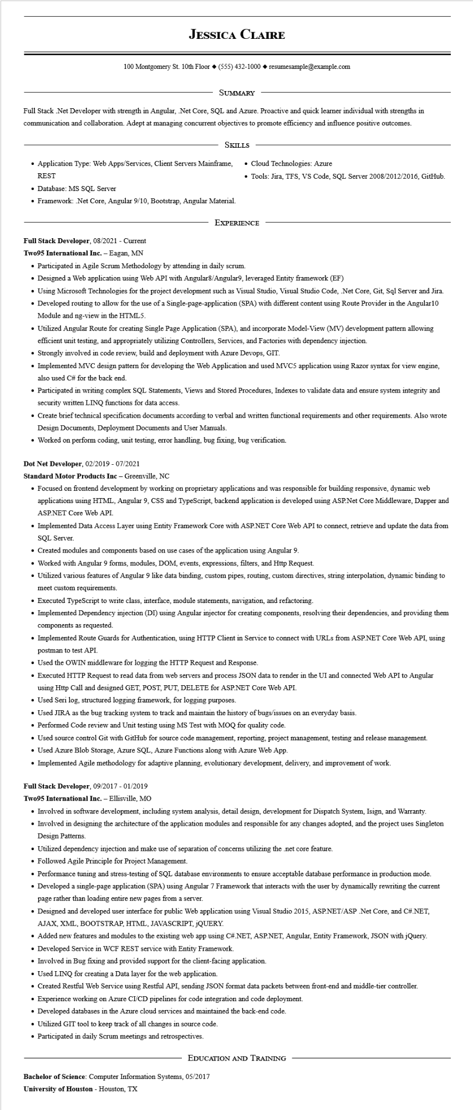
JESSICA CLAIRE
100 Montgomery St. 10th Floor◆ (555) 432-1000◆ resumesample@example.com
SUMMARY
Full Stack .Net Developer with strength in Angular, .Net Core, SQL and Azure. Proactive and quick learner individual with strengths in communication and collaboration. Adept at managing concurrent objectives to promote efficiency and influence positive outcomes.
SKILLS
• Application Type: Web Apps/Services, Client Servers Mainframe, REST
• Database: MS SQL Server
• Framework: .Net Core, Angular 9/10, Bootstrap, Angular Material.
• Cloud Technologies: Azure
• Tools: Jira, TFS, VS Code, SQL Server 2008/2012/2016, GitHub.
EXPERIENCE
Full Stack Developer, 08/2021 - Current
Two95 International Inc. - Eagan, MN
• Participated in Agile Scrum Methodology by attending in daily scrum.
• Designed a Web application using Web API with Angular8/Angular9, leveraged Entity framework (EF)
• Using Microsoft Technologies for the project development such as Visual Studio, Visual Studio Code, .Net Core, Git, Sql Server and Jira.
• Developed routing to allow for the use of a Single-page-application (SPA) with different content using Route Provider in the Angular10 Module and ng-view in the HTML5.
• Utilized Angular Route for creating Single Page Application (SPA), and incorporate Model-View (MV) development pattern allowing efficient unit testing, and appropriately utilizing Controllers, Services, and Factories with dependency injection.
• Strongly involved in code review, build and deployment with Azure Devops, GIT.
• Implemented MVC design pattern for developing the Web Application and used MVC5 application using Razor syntax for view engine, also used C# for the back end.
• Participated in writing complex SQL Statements, Views and Stored Procedures, Indexes to validate data and ensure system integrity and security written LINQ functions for data access.
• Create brief technical specification documents according to verbal and written functional requirements and other requirements. Also wrote Design Documents, Deployment Documents and User Manuals.
• Worked on perform coding, unit testing, error handling, bug fixing, bug verification.
Dot Net Developer, 02/2019 - 07/2021
Standard Motor Products Inc - Greenville, NC
• Focused on frontend development by working on proprietary applications and was responsible for building responsive, dynamic web applications using HTML, Angular 9, CSS and TypeScript, backend application is developed using ASP.Net Core Middleware, Dapper and ASP.NET Core Web API.
• Implemented Data Access Layer using Entity Framework Core with ASP.NET Core Web API to connect, retrieve and update the data from SQL Server.
• Created modules and components based on use cases of the application using Angular 9.
• Worked with Angular 9 forms, modules, DOM, events, expressions, filters, and Http Request.
• Utilized various features of Angular 9 like data binding, custom pipes, routing, custom directives, string interpolation, dynamic binding to meet custom requirements.
• Executed TypeScript to write class, interface, module statements, navigation, and refactoring.
• Implemented Dependency injection (DI) using Angular injector for creating components, resolving their dependencies, and providing them components as requested.
• Implemented Route Guards for Authentication, using HTTP Client in Service to connect with URLs from ASP.NET Core Web API, using postman to test API.
• Used the OWIN middleware for logging the HTTP Request and Response.
• Executed HTTP Request to read data from web servers and process JSON data to render in the UI and connected Web API to Angular using Http Call and designed GET, POST, PUT, DELETE for ASP.NET Core Web API.
• Used Seri log, structured logging framework, for logging purposes.
• Used JIRA as the bug tracking system to track and maintain the history of bugs/issues on an everyday basis.
• Performed Code review and Unit testing using MS Test with MOQ for quality code.
• Used source control Git with GitHub for source code management, reporting, project management, testing and release management.
• Used Azure Blob Storage, Azure SQL, Azure Functions along with Azure Web App.
• Implemented Agile methodology for adaptive planning, evolutionary development, delivery, and improvement of work.
Full Stack Developer, 09/2017 - 01/2019
Two95 International Inc. - Ellisville, MO
• Involved in software development, including system analysis, detail design, development for Dispatch System, Isign, and Warranty.
• Involved in designing the architecture of the application modules and responsible for any changes adopted, and the project uses Singleton Design Patterns.
• Utilized dependency injection and make use of separation of concerns utilizing the net core feature.
• Followed Agile Principle for Project Management.
• Performance tuning and stress-testing of SQL database environments to ensure acceptable database performance in production mode.
• Developed a single-page application (SPA) using Angular 7 Framework that interacts with the user by dynamically rewriting the current page rather than loading entire new pages from a server.
• Designed and developed user interface for public Web application using Visual Studio 2015, ASP.NET/ASP .Net Core, and C#.NET, AJAX, XML, BOOTSTRAP, HTML, JAVASCRIPT, JQUERY.
• Added new features and modules to the existing web app using C#.NET, ASP.NET, Angular, Entity Framework, JSON with jQuery.
• Developed Service in WCF REST service with Entity Framework.
• Involved in Bug fixing and provided support for the client-facing application.
• Used LINQ for creating a Data layer for the web application.
• Created Restful Web Service using Restful API, sending JSON format data packets between front-end and middle-tier controller.
• Experience working on Azure CI/CD pipelines for code integration and code deployment.
• Developed databases in the Azure cloud services and maintained the back-end code.
• Utilized GIT tool to keep track of all changes in source code.
• Participated in daily Scrum meetings and retrospectives.
EDUCATION AND TRAINING
Bachelor of Science: Computer Information Systems, 05/2017
University of Houston - Houston, TX

